**Depth First Tree Transversal**

Depth First Search algorithm(DFS) traverses a graph in a depthward motion and uses a stack to remember to get the next vertex to start a search when a dead end occurs in any iteration.

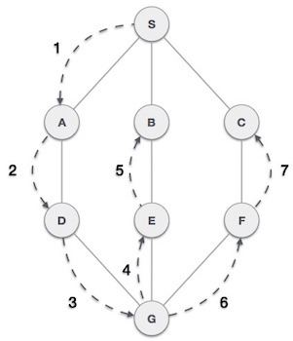

As in example given above, DFS algorithm traverses from A to B to C to D first then to E, then to F and lastly to G. It employs following rules.

* **Rule 1** − Visit adjacent unvisited vertex. Mark it visited. Display it. Push it in a stack.
* **Rule 2** − If no adjacent vertex found, pop up a vertex from stack. (It will pop up all the vertices from the stack which do not have adjacent vertices.)
* **Rule 3** − Repeat Rule 1 and Rule 2 until stack is empty.